TutorTube: Balancing Chemical Equations Summer 2020

Introduction
Hello and welcome to TutorTube, where The Learning Center’s Lead Tutors help you understand challenging course concepts with easy to understand videos. My name is Ethan, Lead Tutor for biology and chemistry. In today’s video, we will explore balancing chemical equations. Let’s get started!

Balancing Chemical Equations
Any chemical reaction that occurs needs to be balanced to be useful. The reason we balance equations is because we must obey the law of conservation of mass. However, much stuff we have on the left side of the equation must equal however much stuff we have on the right side of the equation.

For this example, we have the combustion of ethane to produce water and carbon dioxide. The unbalanced equation has two carbon, six hydrogen, and two oxygen on the left side and one carbon, two hydrogen, and three oxygen on the right side.

$$C_{2}H_{6}+ O_{2} → H_{2}O+CO_{2}$$
C | 2 | 1
H | 6 | 2
O | 2 | 3

To balance it, we start by putting a two in front of the carbon dioxide to give two carbons on the right to match the two carbons we have on the left. When we add the two, we also change the number of oxygen present on the right side. Instead of only three oxygen on the right, now we have four coming from carbon dioxide, and one coming from the water. Therefore, four plus one gives us five total oxygen on the right.

$$C_{2}H_{6}+ O_{2} → H_{2}O+2CO_{2}$$
C: 2 | H: 6 | O: 2 | C: 2 | H: 2 | O: 5

Next, let’s balance the hydrogen.

If we place a three in front of the water, that gives us six hydrogen on the right which matches the six hydrogen on the left. It also gives us seven total oxygen on the right.

$$C_{2}H_{6}+ O_{2} → {3H}_{2}O+2CO_{2}$$
C: 2 | H: 6 | O: 2 | C: 2 | H: 6 | O: 7

To balance the remaining oxygen, we multiply the two oxygen on the left by 7/2 to get seven oxygen on the left.

$$C_{2}H_{6}+ {\frac{7}{2}O}_{2} → {3H}_{2}O+2CO_{2}$$
C: 2 | H: 6 | O: 7 | C: 2 | H: 6 | O: 7

Since we don’t want fractions and can’t have 7/2 amount of O₂, we multiply the whole equation by two.

$${2 x [C}_{2}H_{6}+ {\frac{7}{2}O}_{2} →3H_{2}O+2CO_{2}]$$
C: 2 | H: 6 | O: 7 | C: 2 | H: 6 | O: 7

Now, all the elements on the left match the elements on the right. We have four carbon, 12 hydrogen, and 14 oxygen on the both sides.

$${2C}_{2}H_{6}+7O_{2} →6H_{2}O+4CO_{2}$$
C: 4 | H: 12 | O: 14 | C: 4 | H: 12 | O: 14

Whenever balancing equations try to balance the elements that are grouped together in compounds first, then balance the ones that are alone. Like in the last example we balanced oxygen last since it was alone on the left side of the equation. The elements that are alone have more freedom to be adjusted.

Here’s another example with Al and Fe₂O₃ reacting to produce Fe and Al₂O₃.

$$Al+{Fe}_{2}O_{3} →Fe+ {Al}_{2}O_{3}$$
Al: 1 | Fe: 2 | O: 3 | Al: 2 | Fe: 1 | O: 3

On the left, we have one Al, two Fe, and three O. On the right, we have two Al, one Fe, and three O.

First, we place a two in front of the Al on the left to balance Al.

$$2Al+{Fe}_{2}O_{3} →Fe+ {Al}_{2}O_{3}$$
Al: 2 | Fe: 2 | O: 3 | Al: 2 | Fe: 1 | O: 3
Then, we place a two in front of Fe on the right to balance Fe. And we’re done. We have two Al, two Fe, and three O on both sides of the equation.

$$2Al+{Fe}_{2}O_{3} →2Fe+ {Al}_{2}O_{3}$$
Al: 2 | Fe: 2 | O: 3 | Al: 2 | Fe: 2 | O: 3

Let’s try a tougher one. Ca₃(PO₄)₂, plus SiO_{2,} plus C produces CaSiO_{3,} plus CO, plus P₄. For these ones I like to right out each element on the left and right side to keep track of their amounts. On the left, we have three calcium, two phosphorous, 10 oxygen, one silicon, and one carbon. On the right, we have one calcium, four phosphorus, four oxygen, one silicon, and one carbon.

$${Ca}_{3}{(PO_{4})}_{2}+ SiO_{2}+C →CaSiO_{3}+CO+P_{4}$$
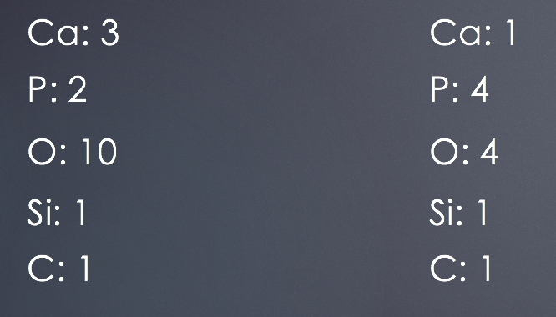
Figure 1: List of total elements in the equation.

Let’s begin by balancing the calcium. To do so, we put a three in front of the CaSiO₃ on the right. Nothing changes on the left, so that all. Stays the same. Now, instead of having one calcium on the right, we have three. Instead of four oxygen, we now have 10 with nine coming from the 3CaSiO₃ and one coming from the CO. Remember to multiply the coefficients by the subscripts for each compound. Since we have a coefficient of three in front of the CaSiO₃ and a subscript of three on the oxygen, we have 3x3 oxygen there, which is equal to nine. And, we now have three silicon as well one carbon.

$${Ca}_{3}{(PO_{4})}_{2}+ SiO_{2}+C →3CaSiO_{3}+CO+P_{4}$$
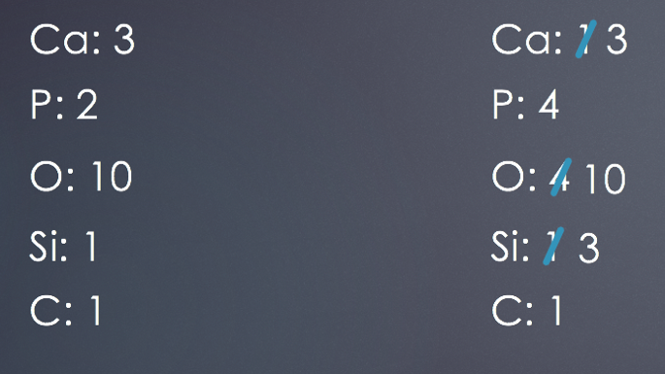
Figure 2: List of total elements in the equation.

Next, we place a two in front of Ca₃(PO₄)₂ on the left to balance the phosphorous. This gives us six calcium, four phosphorus, and 18 oxygen on the left. When calculating the number of phosphorous and oxygen, make sure to remember that a subscript outside a parenthesis applies to each item in the parentheses. Therefore, we have two phosphorous times the coefficient of two out front to give a total of four phosphorous. For oxygen, we have 4x2 which is eight. Then we multiply eight times the coefficient of two to get 16 plus the two oxygen from SiO₂ to give a total of 18 oxygen on the left. Silicon and carbon remain the same, and the right side is. Left untouched.

$$2{Ca}_{3}{(PO_{4})}_{2}+ SiO_{2}+C →3CaSiO_{3}+CO+P_{4}$$
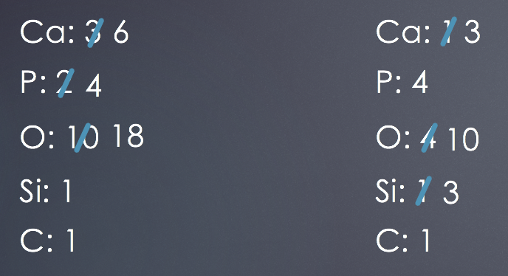
Figure 3: List of total elements in the equation.

Next, we rebalance the calcium by replacing the three in front of the CaSiO₃ with a six. The left side stays the same. Now we have six calcium, four phosphorus, 19 oxygen, six silicon, and one carbon on the right.
$$2{Ca}_{3}{(PO_{4})}_{2}+ SiO_{2}+C →6CaSiO_{3}+CO+P_{4}$$
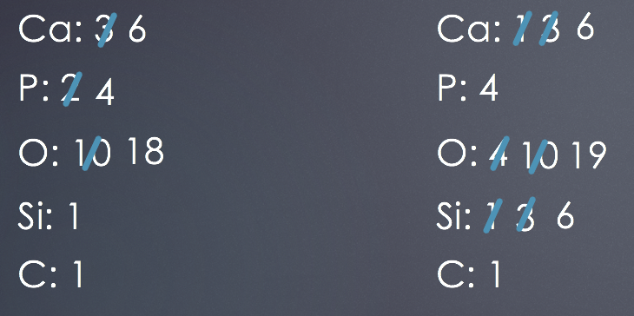
Figure 4: List of total elements in the equation.

After that, we place a six in front of the SiO₂ on the left to balance the silicon. The only thing that changes on the left is the amount of oxygen from 18 to 28 and the number of silicon from one to six.

$$2{Ca}_{3}{(PO_{4})}_{2}+6SiO_{2}+C →6CaSiO_{3}+CO+P_{4}$$
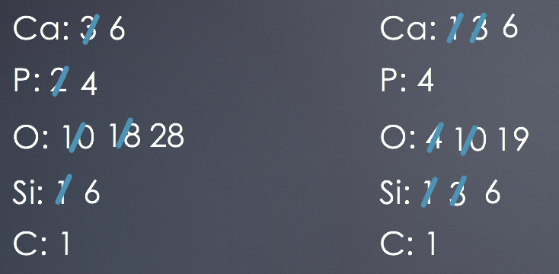
Figure 5: List of total elements in the equation.

All that’s left now is oxygen and carbon. To balance the oxygen, we add a 10 in front of the CO on the right to give us 28 oxygen and 10 carbon.

$$2{Ca}_{3}{(PO_{4})}_{2}+6SiO_{2}+C →6CaSiO_{3}+10CO+P_{4}$$
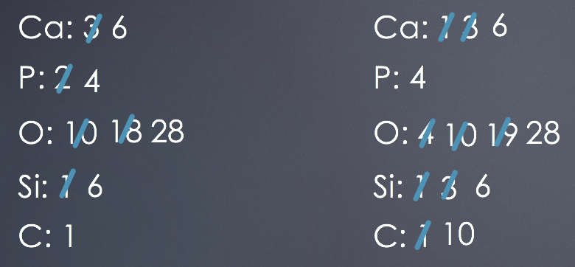
Figure 6: List of total elements in the equation.

Finally, we balance the carbon by placing a 10 in front of the C on the left.

$$2{Ca}_{3}{(PO_{4})}_{2}+6SiO_{2}+10C →6CaSiO_{3}+10CO+P_{4}$$
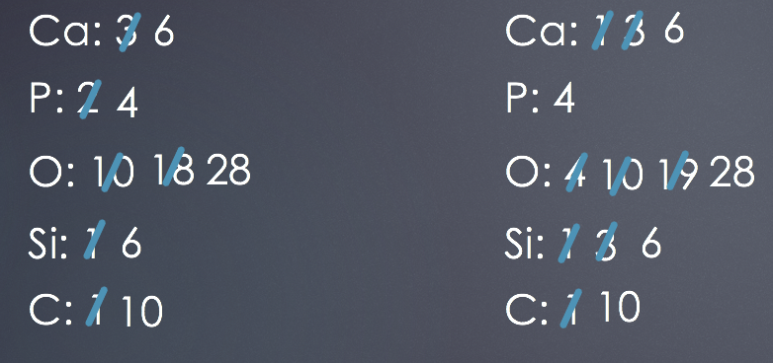
Figure 7: List of total elements in the equation.

This is our fully balanced equation:

$$2{Ca}_{3}{(PO_{4})}_{2}+6SiO_{2}+10C →6CaSiO_{3}+10CO+P_{4}$$

Outro
Thank you for watching TutorTube! I hope you enjoyed this video. Please subscribe to our channel for more exciting videos. Check out the links in the description below for more information about The Learning Center and follow us on social media. See you next time!

